Panel Reference | PPSSTH-150
DA No. | DA-2022/395
Property | 411-417 Crown Street WOLLONGONG
Proposal | Demolition of two (2) residential dwellings and construction of a six (6) storey health services facility with four (4) basement parking levels
Applicant | Coveston Developments Pty Ltd
Prior SRPP meeting | 20 September 2023
BACKGROUND
The proposal was referred to Southern Region Planning Panel at its meeting held on 20 September 2023 for determination pursuant Clause 5 of Schedule 6 of State Environmental Planning Policy (State and Regional Development) 2011 as it consists of private infrastructure and community facilities and has a Capital Investment Value in excess of $5 Million.
The SRPP deferred determination of the application subject to Council providing amended and additional draft conditions of consent for consideration by the Panel and providing additional information in relation to the following matters:
- Expanded response to DRP comments (how the outstanding matters in the DRP report were addressed and how this satisfies the design excellence requirements in the LEP)
- Further details regarding overshadowing impacts on the adjacent RFB to the south (including pre and post development impacts)
- Further details to clarify why Council is of the view that the deferred condition regarding the easement can be satisfied.
- Further discussion and explanation of the operation of the use, particularly during sensitive hours, and appropriate conditions to manage any impacts (POM to manage where deliveries will be made, management of lighting, car parking. Delivery hours, hours of use etc.)
- Review of the allocation of car parking and expanded discussion on the provisions and potential management measures to be included in conditions
- An updated condition set
ASSESSMENT OF THE MATTERS OF CONCERN IDENTIFIED BY SRPP
- Expanded response to DRP comments (how the outstanding matters in the DRP report were addressed and how this satisfies the design excellence requirements in the LEP)
The following comments are provided in relation to matters identified in the DRP Notes dated 19 April 2023 which identified that further details were required to demonstrate that design excellence is achieved in relation to Clause 7.18 of Wollongong Local Environmental Plan 2009.
7.18 Design excellence in Wollongong city centre and at key sites
(4) In considering whether development to which this clause applies exhibits design excellence, the consent authority must have regard to the following matters—
(a) whether a high standard of architectural design, materials and detailing appropriate to the building type and location will be achieved
DRP Comment:
Achieved, provided that refinements are incorporated into the proposal.
Council Comments
The design changes were made to the architectural design. These included:
- Removal of vertical timber screening to service doors off the loading bay and all other service doors and materials changed to match the continuity of the remainder of the ground floor façade.

- A single additional tenancy added at ground floor level. Both the lobby and the single tenancy are now interconnected with glass walls and connection points readily visible from within the ground floor level
- Lifts amended to open directly to the lobby with direct line of sight to the tenancy.
- Planters within the colonnade/loggia amended to enable the colonnade/loggia to act both independently or as one if new development to the west is or is not to contain a colonnade/loggia to the street frontage.
- Wrapped glazing to the western elevation provided to enhance the horizontal elements of the façade which the DRP requested to be emphasised. The remainder of the blank wall on the western façade has been amended to include a painted concrete panel finish with grooved and banded treatment which adds a level of detail to the façade that reduces the visual impact of the western elevation.
- Level 6 has been removed consistent with DRP advice to the extent it will now only be used as a rooftop plant, significantly improving the overall bulk and scale of the upper level built form.
- The plantroom and roof services moved to the centre of the floor to reduce its apparent bulk from street and surrounding viewpoints. A flat projecting roof has also been applied to Level 5 to reduce bulk and scale.
The proposal is considered to adequately address item (a) of Clause 7.18(4).
(b) whether the form and external appearance of the proposed development will improve the quality and amenity of the public domain
DRP Comment:
Achieved, provided that refinements are incorporated into the proposal.
Council Comments
Changes to the facade at the Crown Street frontage have been made to improve the interface with the public way include rationalisation of entry transition elements. Planter beds have been attached to support columns within the undercroft area. The three pedestrian entry/exit points have been reduced to two. The finished surface area of the undercroft is graded to be accessible as well as matched to the levels of the adjoining public footpath. Accessible entry doors to the tenancy direct to the undercroft and independent of, but directly accessible to, the lobby and vice versa.
The proposal is considered to adequately address item (b) of Clause 7.18(4).
(c) whether the proposed development detrimentally impacts on view corridors,
DRP Comment:
No
Council Comments
Noted. The proposal does not have any detrimental impacts on view corridors and the proposal is considered to adequately address item (c) of Clause 7.18(4).
(d) whether the proposed development detrimentally overshadows an area shown distinctively coloured and numbered on the Sun Plane Protection Map,
DRP Comment:
No – although shadow impacts on southern properties must be completely described.
Council Comments
The subject property does not overshadow any properties identified on the Sun Protection Map.
The proposal is considered to adequately address item (d) of Clause 7.18(4).
See further comments in relation to overshadowing on southern properties below in this report.
(e) how the proposed development addresses the following matters—
(i) the suitability of the land for development
DRP Comment:
Suitable
Council Comments
Noted. The proposal is considered to adequately address item (e) (i) of Clause 7.18(4).
(ii) existing and proposed uses and use mix
DRP Comment:
Suitable
Council Comments
Noted. The proposal is considered to adequately address item (e) (ii) of Clause 7.18(4).
(iii) heritage issues and streetscape constraints
DRP Comment:
Achieved, provided that refinements are incorporated into the proposal.
Council Comments
The proposal has no impacts on any heritage items. The proposal with amendments as described above is considered to appropriately address the streetscape constraints.
The proposal is considered to adequately address item (e) (iii) of Clause 7.18(4).
(iv) the location of any tower proposed, having regard to the need to achieve an acceptable relationship with other towers (existing or proposed) on the same site or on neighbouring sites in terms of separation, setbacks, amenity and urban form
DRP Comment:
Achieved, provided that refinements are incorporated into the proposal.
Council Comments
The relationship to buildings on adjacent sites is considered satisfactory. Although the adjacent building to the south in Staff Street is overshadowed by the proposed building, the rear setback is generous, and the shadowing impacts are not primarily as a result of the setback provided.
The proposed nil side setbacks to the east and west encourage a continuous street wall/active street frontage for future development along Crown Street. This is in accordance the requirements of WDCP 2009 which encourages active and continuous street frontages in the City Centre.
The proposal is considered to adequately address item (e)(iv) of Clause 7.18(4).
(v) bulk, massing and modulation of buildings
DRP Comment:
Achieved, provided that refinements are incorporated into the proposal.
Council Comments
The proposal has been significantly improved in terms of bulk and scale through the deletion of one level and relocation of roof plant as described above.
The proposal is considered to adequately address item (e)(v) of Clause 7.18(4).
(vi) street frontage heights
DRP Comment:
Achieved, provided that refinements are incorporated into the proposal.
Council Comments
Noted however street frontage heights only apply to Commercial Core zone and are not applicable to the subject site.
(vii) environmental impacts such as sustainable design, overshadowing, wind and reflectivity,
DRP Comment:
Shadow impacts on southern properties must be completely described.
Council Comments
Further details of overshadowing were provide including in the form of 2D shadow diagrams at hourly intervals and 3D solar access diagrams for 21 June. After the SRPP Meeting on 20 September the applicant has supplied additional 3D solar access diagrams for the winter and spring equinox to assist Council and the Panel in further understanding the impacts of overshadowing. These form attachment 1.
The proposal is considered to adequately address item (e)(vii) of Clause 7.18(4).
(viii) the achievement of the principles of ecologically sustainable development
DRP Comment:
Still to be demonstrated
Council Comments
Appropriate stormwater treatment measures are proposed and supported by conditions of consent. A condition of consent also requires the development to meet ecologically sustainable development requirements in accordance with the recommendations of the environment and sustainability report submitted with application.
The proposal is considered to adequately address item (e)(viii) of Clause 7.18(4).
(ix) pedestrian, cycle, vehicular and service access, circulation and requirements
DRP Comment:
Achieved
Council Comments
Noted - The proposal is considered to adequately address item (e)(ix) of Clause 7.18(4).
(x) impact on, and any proposed improvements to, the public domain.
DRP Comment:
Achieved, provided that refinements are incorporated into the proposal.
Council Comments
The application has been assessed by Council’s landscape, traffic and development engineering officers in relation to the interface of the development with the public domain. The design, as amended has been considered satisfactory and appropriate conditions imposed including submission of a final landscape plan to address compliance with Council’s Public Design Manual.
The proposal is considered to adequately address item (e)(x) of Clause 7.18(4).
Conclusion in repose to DRP matters
The recommendation of the Panel was that provided the above were incorporated into the development it did not need to review the proposal again. Council staff including Council design expert (architect), have assessed final plan amendments and responses provided by the applicant and are satisfied that the development achieves the design excellence requirements of Clause 7.18 of WLEP 2009.
- Further details regarding overshadowing impacts on the adjacent RFB to the south (including pre and post development impacts)
To address this concern the applicant, post meeting provided 3D shadow analysis at the spring equinox (22 September). This analysis is provided as attachment 1 and demonstrates the full extent of overshadowing of the residential flat building at 28-30 Staff Street. Number 28-30 Staff Street has its primary living areas and balconies orientated east-east. This was a specific design approach for that development anticipating future overshadowing by development in Crown Street due to the planning controls and site constrains.
Under DA-2014/512 (28-32 Staff Street) the then Residential Flat Design Code required that 70% of units should receive a minimum of 3 hours of direct sunlight to open and living spaces between 9.00am and 3.00pm on June 21. The assessment noted that 76% of units (26 units out of 34) would receive a minimum of 3 hours of direct sunlight. The assessment also noted that 100% of units would receive a minimum of 2 hours of direct sunlight. The Apartment design Guide now requires that 70% of units should receive a minimum of 2 hours of direct sunlight to open and living spaces between 9.00am and 3.00pm on June 21. A precise re-calculation has not been carried out, but it is estimated that between 60-70% of the open and living spaces of the flat building would continue to receive of 2 hours of direct sunlight. The equinox diagrams show improvement to the extent that the flat building would comply at that time.
The shadow diagrams considered by the Panel at the meeting demonstrated that the impacts are limited to units on the western side of the building. The additional 3D modelling for the spring equinox demonstrates that from 9am until 11am there is no change to existing overshadowing of the west facing balconies, which is a result of the orientation of the building. During morning hours the north facing windows retain full solar access except for the lower floors from 11am onwards.
From 12 Noon to 3pm the west facing balconies of the northern elevation all retain full solar access apart from a portion of lower unit balconies from 1pm onwards.
Further, in relation to overshadowing it is noted that the existing private hospital building on the northern side of Crown Street casts shadow on 28-32 Street from 2pm in mid-winter as demonstrated below.
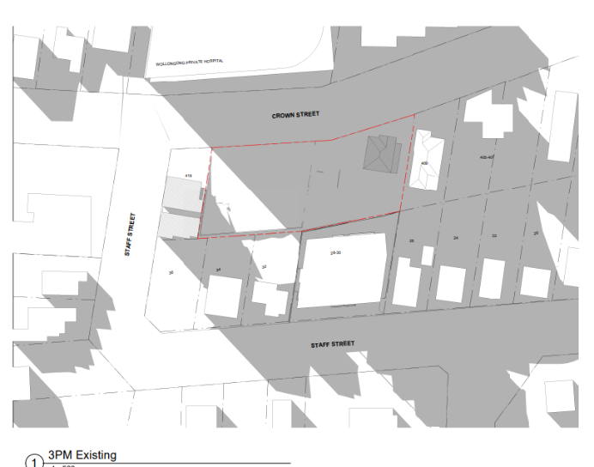
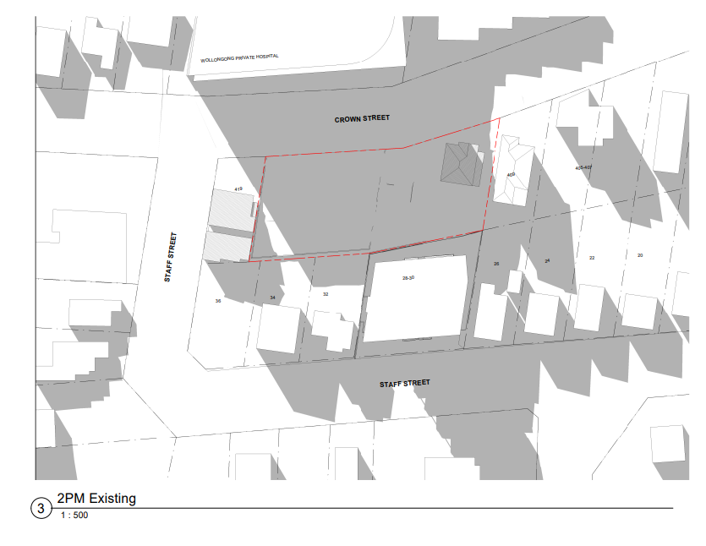
Existing Shadows at 3pm mid-winter
Existing Shadows at 2pm mid winter
- Further details to clarify why Council is of the view that the deferred condition regarding the easement can be satisfied.
The key element from Council’s perspective is ensuring that the design, location and function of the drainage works is understood and appropriate. The land tenure question, as discussed in Council’s assessment report, can be dealt with via a deferred commencement condition, or by an application by an applicant under sec 40 (or sec 88K of the Conveyancing Act 1919 if appropriate). Council’s Stormwater Engineer has considered the drainage design submitted by the applicant which proposes to discharge part of the site to Crown Street via an OSD system and discharge the rear component of the site via an easement.
The easement as proposed incorporates a 225 mm pipe which requires a minimum 1m wide easement over lot 34 DP8682 which adjoins the development to the rear. The proposed easement is as per Table 5 of WDCP Chapter E14- Stormwater Management and is considered a satisfactory means of stormwater disposal. Photographs provided to the Panel at the meeting demonstrate that the establishment of the easement and provisions of a 225mm stormwater pipe is feasible having regard to the nature of the site i.e. there are no significant vegetation or structures which would prevent the easement from being created.
From Council’s perspective the design, location and function of the drainage works is understood and appropriate.
- Further discussion and explanation of the operation of the use, particularly during sensitive hours, and appropriate conditions to manage any impacts (POM to manage where deliveries will be made, management of lighting, car parking. Delivery hours, hours of use etc.), and
- Review of the allocation of car parking and expanded discussion on the provisions and potential management measures to be included in conditions.
In relation to the above, the applicant has advised that as no tenants are in place at this time it is not possible to provide a plan of management in relation to allocation of car parking. Notwithstanding, a condition of consent is proposed to ensure that parking is equitably shared between future tenants, patients and visitors. The applicant’s planning consultant has suggested that it would be appropriate to address potential concerns regarding delivery times through conditions of consent addressing matters such as:
- after-hours authorised access only - or CCTV monitoring or similar.
- hours and days of deliveries,
- external lighting and glare control
- and certification of noise generating plant and equipment for to the issue of OC
Additional conditions have been recommended to address noise and amenity issues and operation of the car park and noise generating activities. The additional conditions proposed are:
Before the Issue of an Occupation Certificate
108B Green Travel Plan
108C Car Parking Allocation
108D Plan of Management – Protection of Amenity
111A. Noise Control General
111B. Noise Control – Plant and Machinery
111C Loading and Unloading
111D Unobstructed Driveways and Parking Areas
Other conditions have been amended to address issues raised by the Panel. The proposed changes can be seen in the attached ‘track changes’ version of the draft conditions.
- An updated condition set.
An updated set of draft conditions using ‘Track Changes’ is attached (‘all mark up’ and ‘no mark up’ versions provided). To avoid any confusion new conditions have used numbering to prevent a re-numbering of the document. The updated conditions include changes to address comments made by the Panel at the meeting and additional conditions addressing the maters above.
CONCLUSION
The Panels request for amended/additional conditions of consent to be prepared and additional information has been addressed. The application is referred to the Panel for determination in accordance with its request made on 20 September 2023.
RECOMMENDATION
It is recommended that Development Application DA-2022/395 be granted consent pursuant to Section 4.16(3) of the Environmental Planning & Assessment Act 1979, subject to the revised conditions contained in attachment 2.

